**The 5 Best Gifts for Your Pets: Treating Your Furry Friends**

Our pets aren’t just animals—they’re a part of the family. They fill our lives with joy, comfort, and unconditional love, so why not show them just how much they mean to us? Whether it’s a holiday, their birthday, or just because, treating your furry friend to something special is a great way to make their day (and yours!) even better. As a pet parent myself, I’ve rounded up five gifts that are sure to make your pet’s tail wag with excitement. Trust me, they’ll love these!

### ****1. A Comfortable Pet Bed****

Every pet deserves a cozy place to rest, and a plush pet bed can make all the difference in their comfort. Look for beds made from soft, durable materials with a washable cover to keep them fresh. Orthopedic options are great for older pets or breeds prone to joint issues, while heated beds are perfect for chilly nights. Your pet will appreciate having their own designated spot to nap in style and comfort.

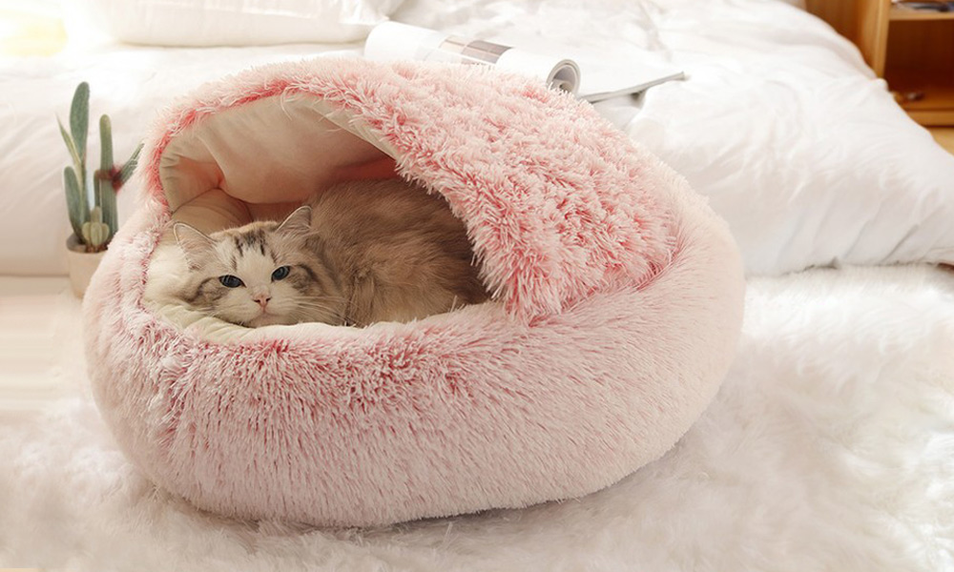

Recommendation: CozyPaws Pet Bed

CozyPaws Pet Bed offers unmatched comfort with its extra-thick pad and soft, fluffy material that retains pets' familiar scents for added security. Designed with orthopedic support, it’s perfect for pets with arthritis or mobility issues, providing a cozy sanctuary that promotes relaxation and well-being.

### ****2. Interactive Toys****

Keep your pet entertained and mentally stimulated with interactive toys. For dogs, try puzzle feeders or chew toys that dispense treats—these keep them busy and challenge their problem-solving skills. Cats will love laser pointers, feather wands, or trackball toys that mimic the thrill of a hunt. Interactive toys not only fight boredom but also help curb destructive behaviors, making them a win-win for both you and your furry friend.

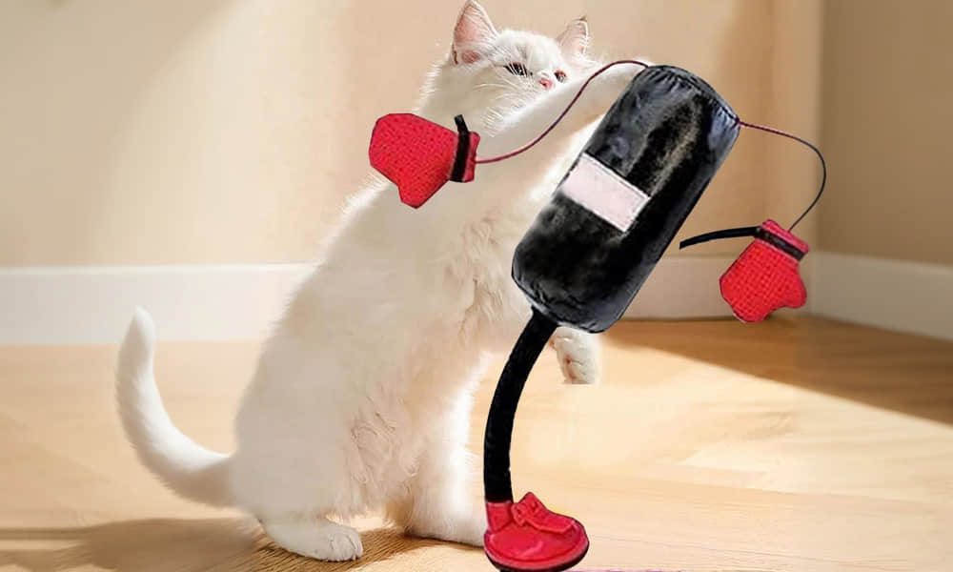Recommendation: PetsBoro Paw Boxer

PetsBoro Paw Boxer is a mini punching bag toy with a durable, springy design that makes crinkle sounds and bell rings. It helps pets release energy, stay entertained, and promote a calmer, more peaceful home.

### ****3. A Personalized Collar or Tag****

Add a touch of personality to your pet's look with a customized collar or tag. Engrave their name and your contact information on a stylish tag to ensure their safety while looking chic. Collars come in all colors and patterns, so you can match their unique personality, whether they’re playful, regal, or somewhere in between. It’s a small gift that combines practicality with charm.



Recommendation: GoTags

GoTags Dog Collar is a stylish and durable collar that you can personalize with vibrant colors and unique embroidery. Made from premium nylon, it’s adjustable for all sizes and breeds, offering both comfort and longevity. This collar keeps your pet safe and looking fabulous while eliminating the hassle of noisy tags.

1. **A Smart Pet Water Feeder**

Keep your pet hydrated even when you're not home with a smart water feeder. These innovative gadgets allow you to schedule water refills or monitor the water level remotely through an app, ensuring your pet always has access to fresh water. Some models even come with built-in cameras, so you can check in on your furry friend while you're away. It’s a thoughtful, practical gift that combines technology with care, offering both convenience and peace of mind for pet owners.

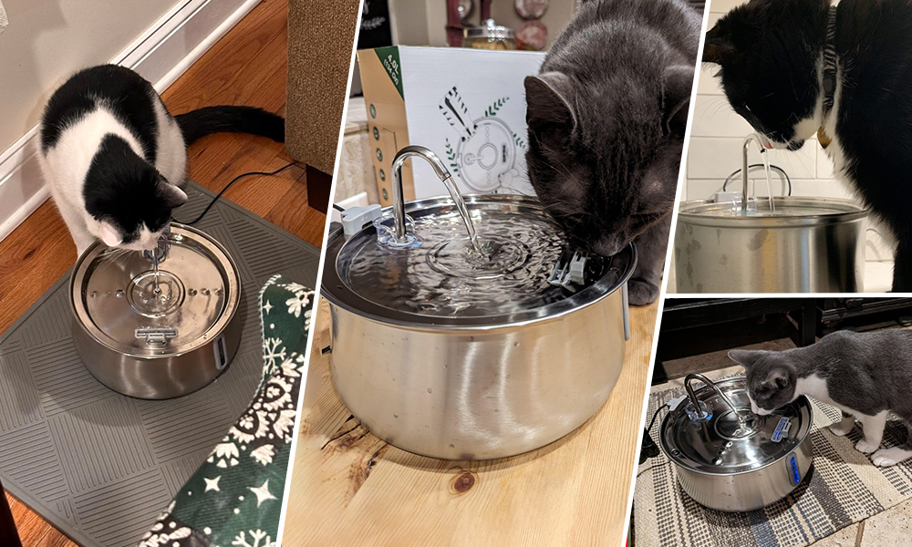

Recommendation: MeowJoy Water Fountain

MeowJoy features a 4-level filtration system that removes 98% of impurities, including fur, odors, chlorine, and heavy metals, ensuring your pet always has access to clean, fresh water. This helps improve their health by preventing common issues like kidney disease and urinary tract infections while keeping their coat soft and shiny.

### ****5. A Plush Chew Toy****

Chew toys are more than just entertainment—they’re essential for your pet’s mental and dental health. Look for a plush chew toy with durable stitching that can withstand some rough play. Bonus points if it squeaks or crinkles, adding extra fun to playtime! For teething puppies, a soft but sturdy chew toy can provide comfort, while adult dogs will enjoy the challenge of gnawing on a resilient toy. It's a simple yet highly appreciated gift for any pet.

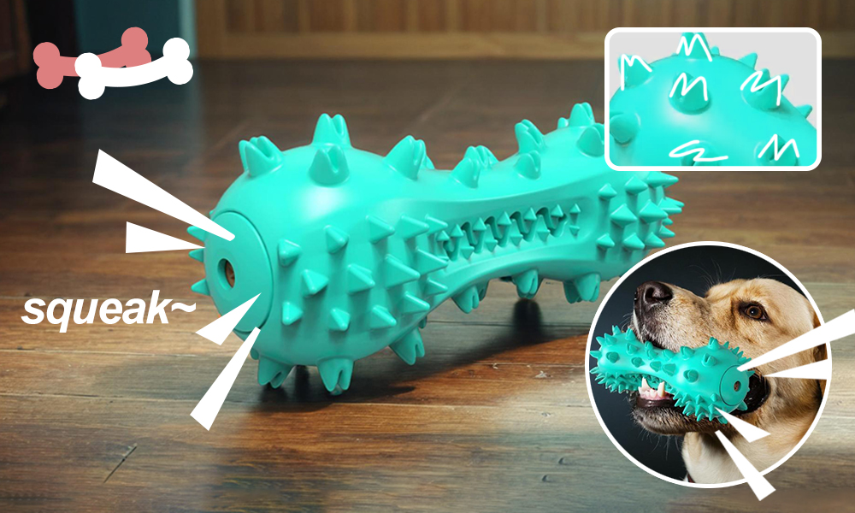

Recommendation: PetsBoro Bionic Bone

PetsBoro Bionic Bone is made from durable, non-toxic natural rubber, offering a safe and long-lasting chew experience. It's flexible yet tough, providing comfort for dogs' gums, especially during teething, and is resistant to wear and tear. The eco-friendly, biodegradable material ensures a satisfying chew without harming your pet’s teeth.

Spoiling your pets with thoughtful gifts is a great way to show them how much you care. Whether it's a cozy bed, a fun toy, or a practical accessory, these gifts are sure to make your furry friends feel loved and appreciated. So next time you're thinking about treating your pet, keep these ideas in mind—they'll love you for it! After all, our pets bring so much joy into our lives, and they definitely deserve a little something special now and then.